Cases >> new case

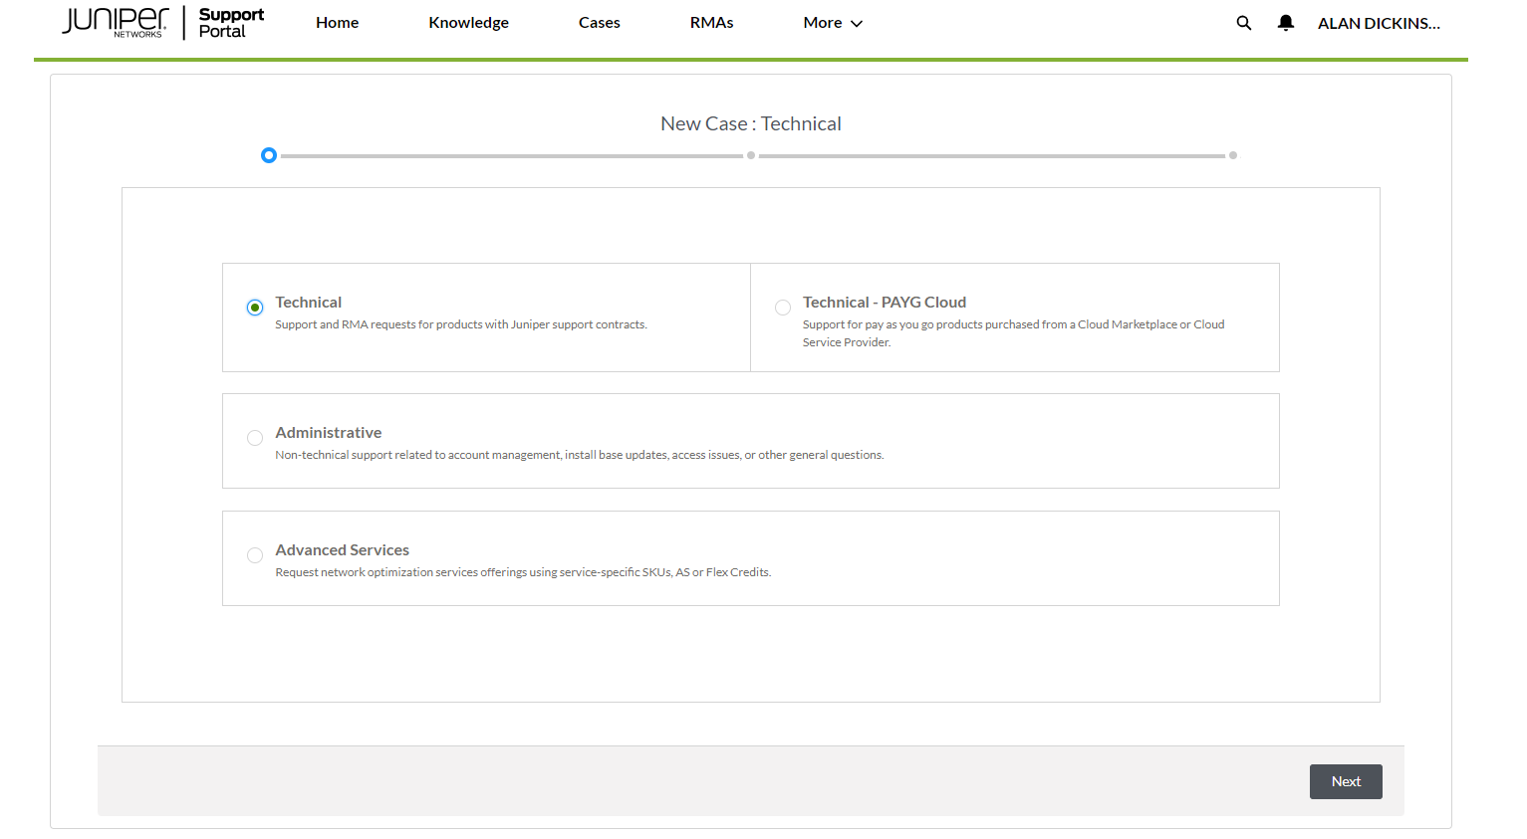

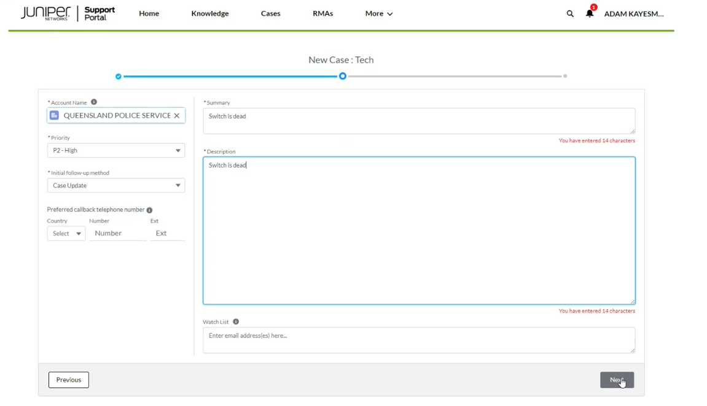

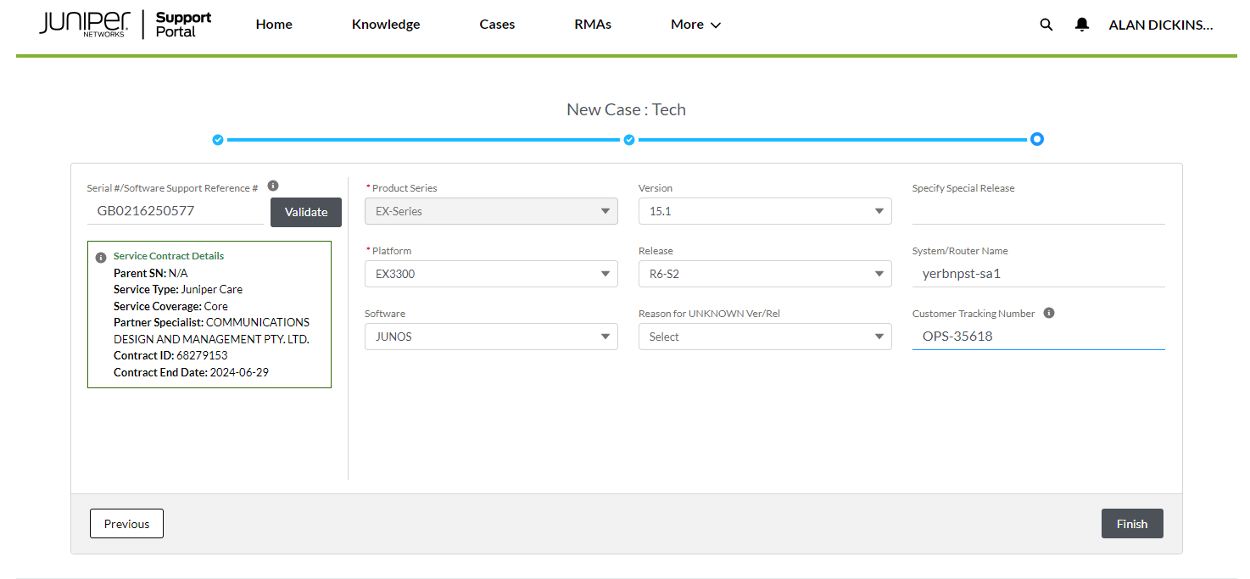

<<< see capture below for where to get info from.

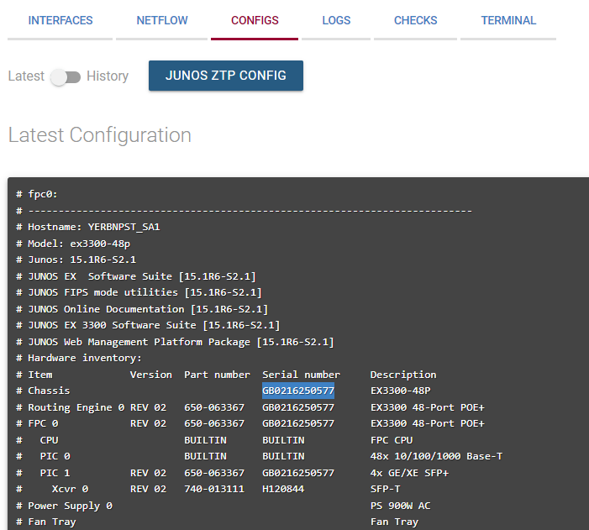

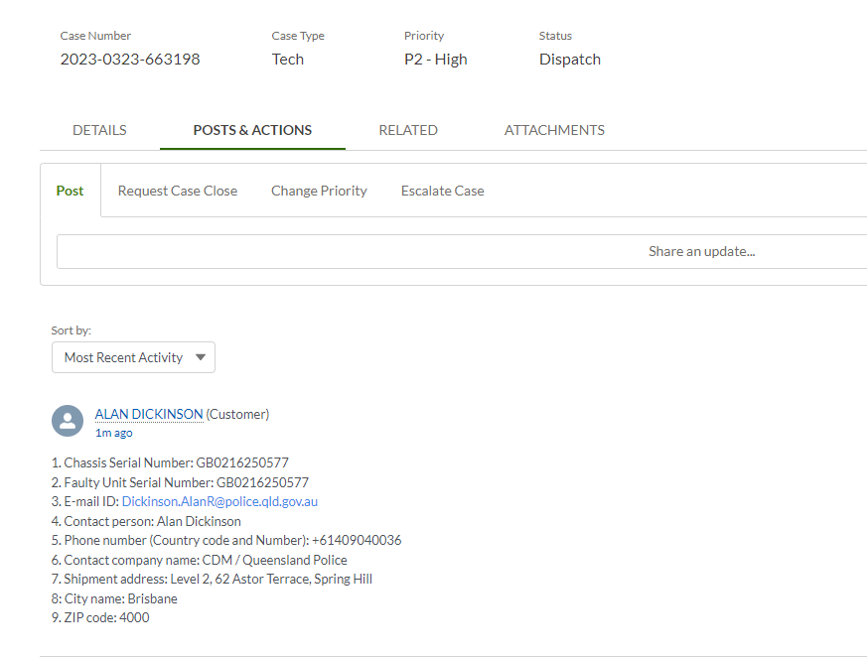

Enter details into “Share an update”….

[Dickinson.AlanR@police.qld.gov.au](mailto:Dickinson.AlanR@police.qld.gov.au)

Alan Dickinson

+61409040036

CDM / Queensland Police

Level 2, 62 Astor Terrace, Spring Hill

Brisbane

4000

1. Chassis Serial Number: GB0214440173

2. Faulty Unit Serial Number: GB0214440173

3. E-mail ID: Dickinson.AlanR@police.qld.gov.au

4. Contact person: Alan Dickinson

5. Phone number (Country code and Number): +61409040036

6. Contact company name: CDM / Queensland Police

7. Shipment address: Level 2, 62 Astor Terrace, Spring Hill

8: City name: Brisbane

9. ZIP code: 4000

************************ CDM

Submit New Ticket

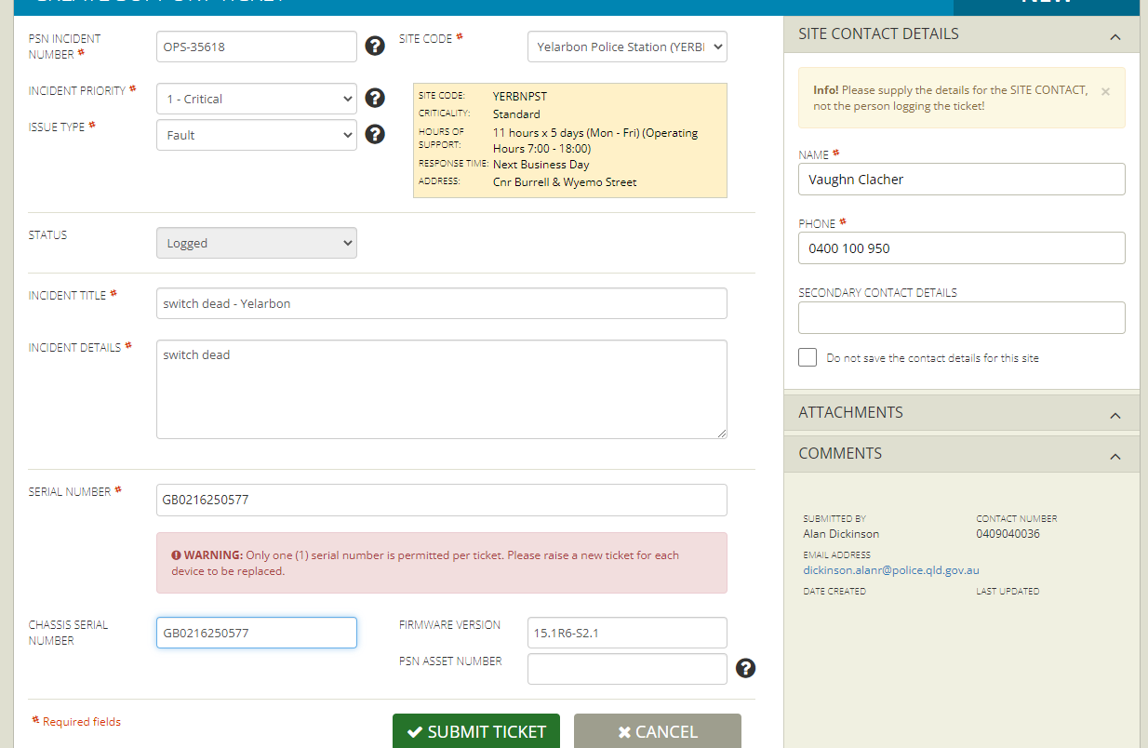

<<< switch details from PSN capture above

Get config from Akips…

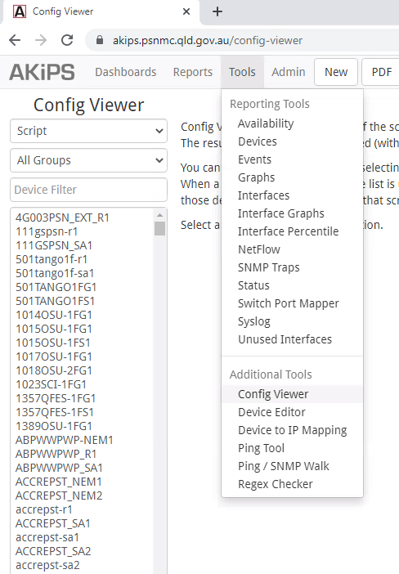

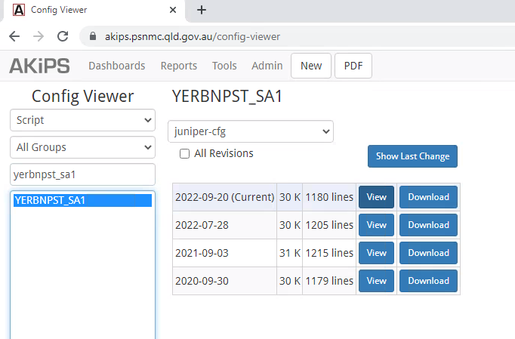

**Cut & paste config to notepad ( carefull to not include the trailing “{master:0}”**

Upload config to CDM ticket >>>

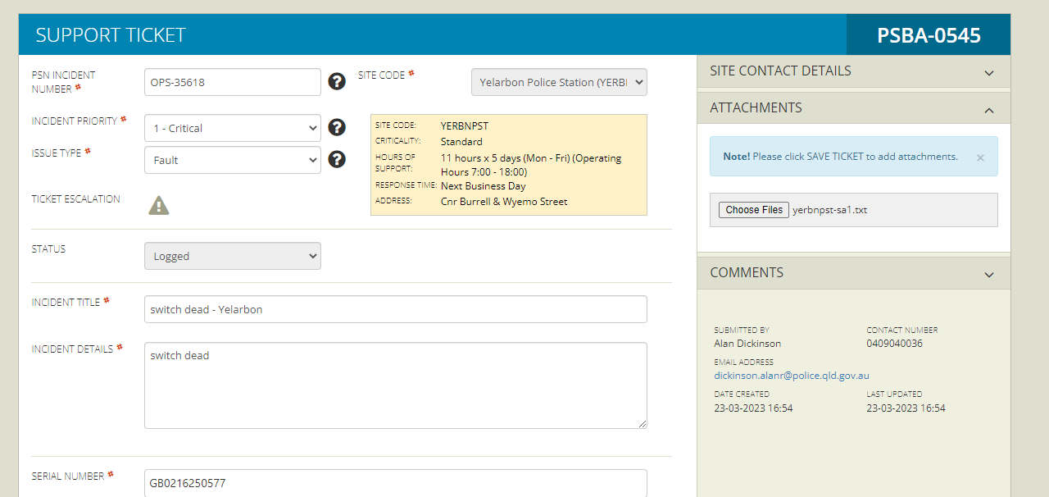

Once Juniper provide the RMA, put the detail in both CDM and OPS ticket.